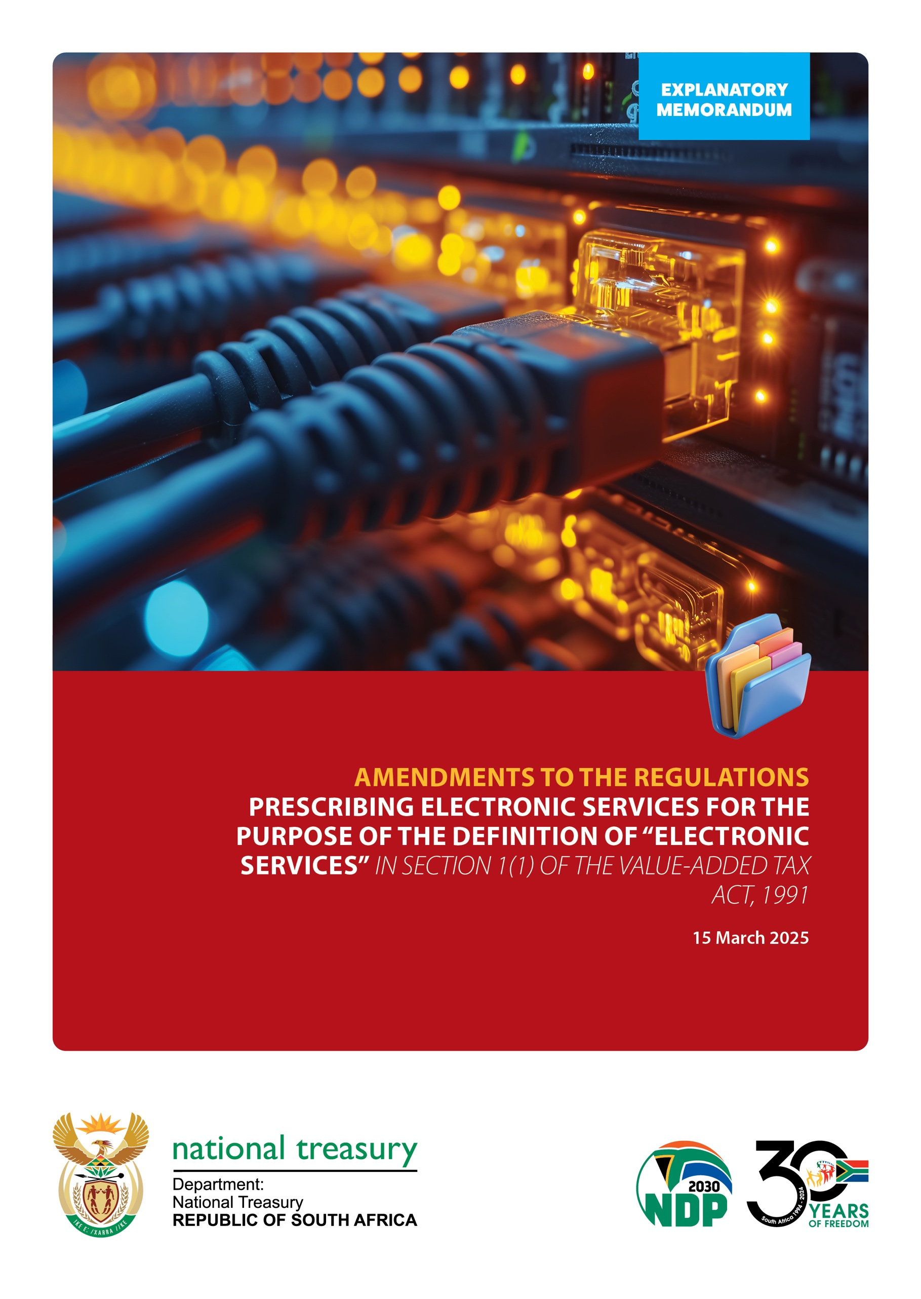

Table of Contents

1. background 1

2. Reasons for change 1

3. Proposals 2

4. IV Effective Date 4

1. background

Effective 1 April 2019 government introduced amendments to the Regulations prescribing electronic services for the purposes of the definition of “electronic services” in section 1(1) of the Value-Added Tax Act, 89 of 1991 (“the VAT Act”). In terms of these amendments, the scope of the regulations was expanded to include all “services” as defined in the VAT Act that are supplied by means of an electronic agent, electronic communication or the internet, for any consideration.

The explanatory memorandum to those amendments stated that the policy intention was to subject to VAT those services that are provided using minimal human intervention

The regulations contained certain exclusions, such as certain educational services and telecommunications services. Since the VAT Act did not exclude supplies between businesses in a domestic context, it was deemed imprudent to exclude such supplies within the context of the regulations. However, to provide relief for administrative burdens related to the cross-border supplies of electronic services between companies within the same group, certain supplies within a group were also excluded.

Consequential amendments to the VAT Act introduced the concept of an ‘’intermediary”. An intermediary is deemed to be the supplier where such intermediary facilitates the supply of the electronic services for an underlying supplier and where such intermediary is responsible for the issuing of the invoice and the collection of the payment. The explanatory memorandum for those amendments further clarified that the requirement of the intermediary being “responsible for” the issuing of the invoice or the collection of the payment would still be met even if such functions were outsourced, provided that the intermediary bore the ultimate responsibility to ensure that these occurred. The policy rationale behind this was to exclude from the scope of the regulations and the VAT Act, those intermediaries that were pure payment platforms and did not partake in any other way with the supply.

Further, in keeping with the Guidelines developed by the Organisation for Economic Cooperation and Development (“OECD”)[1], which guidelines have been endorsed by G20 and non G20 countries and the multinational business community, SARS had provided for a simplified VAT registration regime that reduced the compliance burden on offshore suppliers that were required to register for VAT in terms of the VAT Act and the amended regulations.

1. Reasons for change

Since the digital economy is constantly evolving, it is necessary to constantly review South Africa’s VAT legislation in this regard. Further, as global and domestic experience in this relatively new arena of tax legislation grows, lessons are learned and amendments may be necessary, especially in the sphere of tax administration. Further, technological advances may facilitate certain amendments.

1. Proposals

Certain amendments were proposed in 2020, but since the Covid 19 legislative urgencies overtook events, these proposed amendments were never enacted. It is proposed that these be included now, which relate to adding a new definition of “content” and revising the definition of “telecommunications services” to expand on the meaning of “telecommunications system” that was contained within that definition. “Content” was excluded from the definition of “telecommunications services” hence it became necessary to define “content”.

Taxpayers requested clarity relating to supplies between group of companies, specifically with regard to global contracts. The proposed amendment to regulation 2(c)(ii) provides this clarity. This regulation is being retained despite the new exclusion being introduced as regulation 2(c)(d) to cover situations where the domestic company may not yet be a “vendor” as defined in the VAT Act.

The new proposed exclusion being introduced as regulation 2(c)(d) relates to services provided from a place in an export country by a non-resident person where such supplies are made solely to vendors that are registered in the Republic in terms of section 23 of the VAT Act. This is a form of “business-to-business” (“B2B”) exclusion that applies to supplies made to registered vendors. The policy rationale behind this is to ease the administrative burden on such suppliers and recipients where there is little or no gain to the fiscus. The explanatory memorandum to the 2019 amendments stated that this was not excluded at the time due to concerns relating to fairness and equity between offshore suppliers and domestic suppliers. These concerns still exist; however, non-compliance is easier dealt with and litigated domestically than across borders. With that in mind, government has reconsidered its position and is proposing this amendment to ensure that this VAT regime is as simplified as possible for non-resident suppliers that have no physical presence in the Republic, in line with the globally accepted OECD recommendations[2], to encourage compliance where legal jurisdiction to enforce compliance may be a challenge. These supplies will still be liable for VAT under section 7(1)(c) which relates to the recipient declaring VAT on imported services.

Further, the intention, by using the word “solely”, is to exclude those electronic services suppliers that supply to registered vendors only. Electronic services suppliers that make supplies both to vendors and non-vendors will be subjected to these regulations (i.e. not excluded) and must utilise the value of the supplies to all vendors and non-vendors to determine registration liability. Once registered, such supplier will be required to levy VAT on all supplies of electronic services, to vendors and non-vendors. The rationale for not excluding such suppliers from these regulations (i.e. for not introducing a full B2B exclusion) is due to the complexities that would present to suppliers, in trying to identify a recipient’s status on a case-by-case basis.

It is further proposed that amendments be made to section 54(2B) of the VAT Act. The first amendment relates to the requirement that the underlying supplier (the principal) is not a registered vendor. This requirement is being deleted since it is the intention to hold the intermediary responsible for all supplies made through its platform, including supplies made by principals that are not residents of the Republic, irrespective of their VAT status in the Republic, where such principal and intermediary have agreed, in writing, that the supply will be treated as being that of the intermediary. The policy rationale behind this is to ease the administrative burden on the principal, to ensure that VAT is not accounted for twice (by the principal and the intermediary) on the same supply and to facilitate ease of compliance checks and audits.

The second amendment to this section is to introduce a second sub-section that introduces the concept of a joint and several liability for both the principal and the intermediary in instances where both parties have agreed to treat the supplies as being made by the intermediary. Both parties will be held jointly and severally liable for performing the duties of the principal or the intermediary under the VAT Act and paying the tax imposed by the VAT Act in respect of those taxable supplies that were made under the agreement.

Finally, despite the words “minimal human intervention” being used in the explanatory memorandum for the 2019 amendments, these words or this concept was never introduced in either the VAT Act or the regulations. The intention was for the interpretation of these regulations to be done within the spirit of that concept. The policy rationale behind these regulations is to address the tax challenges of the digital economy from a South African VAT point of view. This is in line with the Base Erosion and Profit Shifting concerns raised by the G20 Finance Ministers and addressed through the OECD’s various guidelines dealing with electronic commerce across borders. Perhaps the 2019 Explanatory Memorandum ought to have used the words “electronic commerce across borders” rather than the words “minimal human intervention” since it has come to government’s attention that this term is now being challenged by non-resident suppliers who are trying to avoid VAT registration in the Republic.

For example, some developers of software believe that the development of their product took many man-hours of human intervention to develop and that the subsequent supply thereof is merely done through an electronic medium, similar to an attorney emailing his legal opinion. This interpretation is clearly contrary to the government’s policy intention when the 2019 amendments and explanatory memorandum were drafted. To combat such blatant misinterpretation, it is recommended that the interpretation of which services fall within these regulations and the VAT Act, be as strict as possible, within the confines of the legislation, with no regard to the words “minimal human intervention”, since these words do not appear in the legislation.

In terms of the provisions of section 23(1A), which was gazetted on 05 January 2023, via Government Gazette No. 47827, relief was granted from the requirement to register where the value of the taxable supplies reaches the threshold solely as a consequence of abnormal circumstances of a temporary nature. This provision will cater for suppliers that were not intended to be caught by the provisions of these regulations.

1. IV Effective Date

The proposed amendments come into operation on 1 April 2025.

1. OECD “International VAT / GST Guidelines”, 2017 and “Mechanisms for the Effective Collection of VAT / GST”, 2017
2. OECD “International VAT / GST Guidelines”, 2017 and “Mechanisms for the Effective Collection of VAT / GST”, 2017